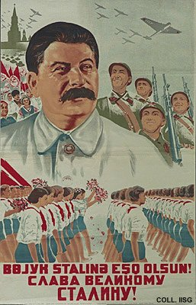 |  | Sirocenqo, 1938  Long live the great Stalin!  (Lithography, 93.5x60 cm., inv.nr. BG E11/933)  A parade, tanks, military airplanes and soldiers: Stalin may be smiling friendly, but war preparations are in full swing.

