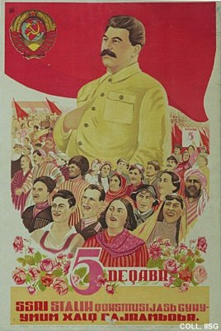 |  | E. Mirzoev, 1938  December 5  (Lithography, 89x60 cm., inv.nr. BG E11/935)  A giant Stalin amid Azerbaijani peoples celebrating the anniversary of the introduction of the new constitution of the Soviet Union.

