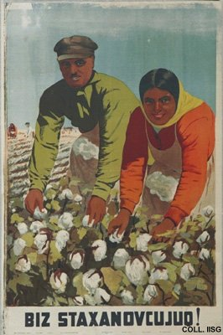 |  | Lebeshev, 1936  We do like Stachanov!  Publisher: Izo-Azernesr, Baku  (Lithography, 95x65 cm., inv.nr. BG E11/931)  Stachanov, a miner achieving incredibly high production figures, is held up as shining example for workers throughout the Soviet Union. Here he is emulated by Azerbaijani cotton workers. Many years later, Soviet authorities admitted that Stachanov was assisted by a team of miners when he performed his heroic feats.

