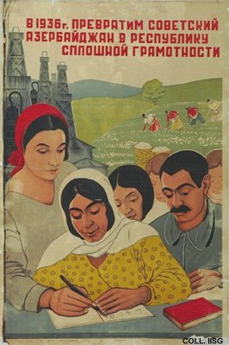 |  | Dors, 1936  We will change the Soviet Republic of Azerbaijan into a republic of abundant literacy  Publisher: Izo-Azernesr, Baku  (Lithography, 95x65 cm., inv.nr. BG E11/927)  Campaign against illiteracy in Azerbaijan. In the background the two natural resources of the region: oil and cotton.

