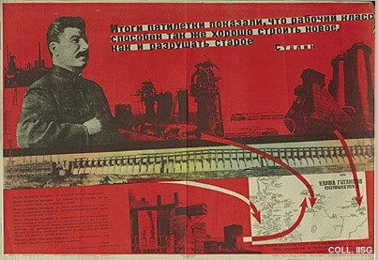 |  | G. Brylov, 1933  The giants of the Five Year Plan  Publisher: Ogiz-Lenizogiz, Leningrad  (Lithography, 70x1005. cm., inv.nr. BG E5/597, coll. Rose)  Stalin towers over the great works of the Five Year Plan, such as the dam in the river Dnepr and the industrial complexes in Magnitogorsk and Stalinsk. Working conditions on these projects are terrible, and large numbers of political prisoners do forced labour. The quote from Stalin above reads: 'The results of the Five Year Plan show that the working class is not only capable of destroying the old, but also of building the new'.

