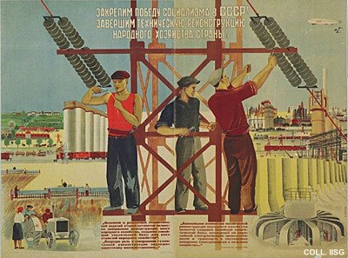 |  | Konstantin Vyalov, 1932  Let's consolidate the victory of socialism in the USSR! Let's technically reconstruct the country's economy!  Publisher: Ogiz-Izogiz, Moscow/Leningrad  (Lithography, 90x120 cm., inv.nr. BG L3/29)  Idealized workers and idyllic scenes from agriculture and industry: the influence of socialist realism is evident. The overall composition however owes much to the constructivist photomontages.

