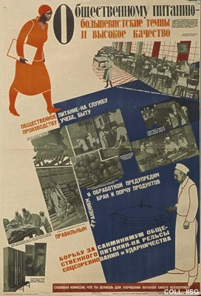 |  | Ogarkov and Lyubimov, 1931  For the society's food supply - bolshevist tempo and high quality  Publisher: Ogiz-Izogiz, Moscow/Leningrad  (Lithography, 104.5x71 cm., inv.nr. BG E5/587, coll. Rose)  The quality of food and service in communal eating houses and canteens is denounced in this unusually explicit poster. Even the 'completely unacceptable sanitary conditions' in some establishments are mentioned.

