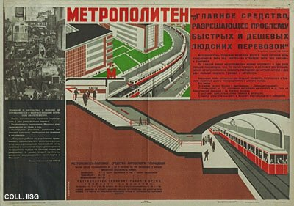 |  | Nikolay Dolgorukov, 1931  Metropolitan  Publisher: Izogiz, Moscow  (Lithography, 73x101.5 cm., inv.nr. BG E5/580, coll. Rose)  In 1931, the Central Committe of the Communist Party decides to the building a subway system in Moscow. This becomes a prestige project for which no pain nor expense is spared. The first line is opened for the public in 1935. On the poster, the chaos of traffic in the old center of Moscow in the photomontage left is contrasted with the spaciousness and efficiency in the large drawing. Bold contrasts such as these are the trademark of designer Dolgorukov.

