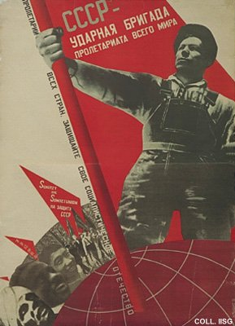 |  | Gustav Klutsis, 1931  The USSR is the crack brigade of the world proletariat  Publisher: Izogiz, Moscow/Leningrad  (Lithography, 142x103 cm., inv.nr. BG M1/133, coll. Rose)  One of Klutsis' most famous photomontages. With the heavily emphasized diagonal, the dynamic composition and the strong contrasts, this poster is one of the classics of Constructivism. The first impression of 30.000 copies had a selling price of 80 copecks, which is next to nothing. The estimated market value of a copy in good condition nowadays is over $ 10.000.

