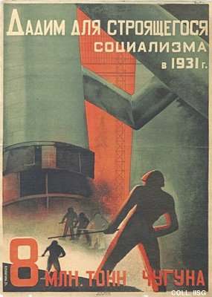 |  | Valentina Kulagina, 1931  8 Million tons of pig iron  Publisher: Ogiz-Izogiz, Moscow  (Lithography, 73x52 cm., inv.nr. BG E5/583)  Kulagina cooperated closely with her husband, the artist Gustav Klutsis. Only a few posters appeared in her own name. They show her exceptional talent, where her contribution to Klutsis' designs can not be determined exactly.

