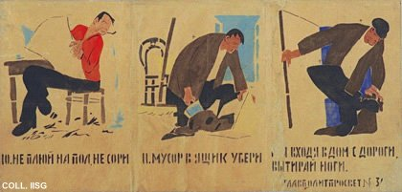 |  | Mikhail Cheremnykh, 1921  10. Don't spit on the floor and don't make a mess. 11. Throw rubbish in the dustbin. 12. And wipe your feet upon entering the house.  Publisher: Glavpolitprosvet, Moscow  (Stencil, 53x110.5 cm., inv.nr. BG L3/19)  Fourth part of a Rosta. See also nrs. 11 (with commentary), 12 and 13.

