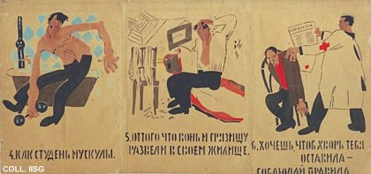 |  | Mikhail Cheremnykh, 1921  4. Their muscles like jelly? 5. Because they admit stench and dirt in their home. 6. If you want disease to leave you alone, observe the following rules:  Publisher: Glavpolitprosvet, Moscow  (Stencil, 53x110.5 cm., inv.nr. BG L3/17)  Second part of a Rosta. See also nrs. 11 (with commentary), 13 and 14.

