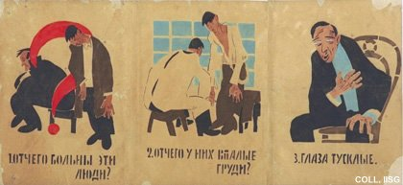 |  | Mikhail Cheremnykh, 1921  1. Why are these people ill? 2. Why is their chest hollow? 3. Their eyes dull?  Publisher: Glavpolitprosvet, Moscow  (Stencil, 53x111.5 cm., inv.nr. BG L3/16)  This poster, a so-called 'Rosta', consists of twelve pictures, mounted in four strips. Rosta's are printed with stencils, in very small impressions. They consist of schematical pictures with short texts, often in rhyme. Rosta's are usually associated with the poet Vladimir Mayakovsky, who writes most of their texts and sometimes draws the pictures as well. Cheremnykh is the inventor of the genre, however, and designs about 500 Rosta's between 1919 and 1922. This Rosta provides basic information on health and hygiene. See also nrs. 12, 13 and 14.

