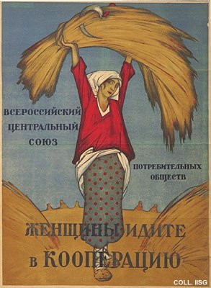 |  | Designer unknown, 1917  Women, adhere to the cooperation  Publisher: All-Russian Central Union of Consumer Cooperations  (Lithography, 71x52.5 cm., inv.nr. BG E5/499)  A poster issued only one or two months after the Bolshevik takeover. The image is traditional, the typography unsophisticated, but the composition and the deep, contrasting colours lend this poster great charm.  site.

