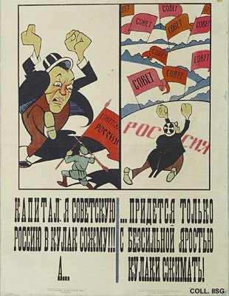 |  | Viktor Deni, 1920  Capital: I will crush Soviet Russia in my fist!!! But... it only clenches its fist in impotent anger!  Publisher: Zapasnaja Armija Respubliki, Kazan  (Lithography, 70.5x54 cm., inv.nr. BG E11/747)  The red flag in the left image says 'Soviet Russia', the flags in the right image 'Soviet'.

