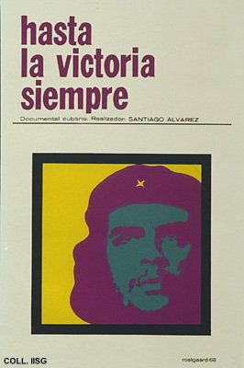 |  | Alfredo Rostgaard, 1968  To victory, always  Publisher: ICAIC  (Silkscreen, 76.5x51 cm., inv.nr. BG E3/921, coll. Martinez)  Poster for a documentary on Che Guevara, made by Santiago Alvarez at the personal request of Fidel Castro immediately after the announcement of Che's death. The film was shown for the first time at the memorial meeting for Che Guevara on the Square of the Revolution in Havana.  The title of the film is taken from Che's farewell letter to Castro, written just before he left Cuba to fight in Bolivia. The photo used by Rostgaard is the classic Che portrait, reproduced in countless variations and available as a poster to this very day.  The Stedelijk Museum of Amsterdam owns a copy of this poster signed by Reboiro instead of by Rostgaard; it may have been a collective piece of work

