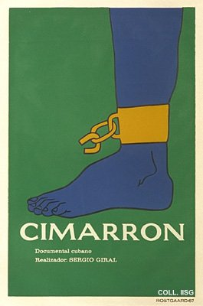 |  | Alfredo Rostgaard, 1967  Cimarron  Publisher: ICAIC  (Silkscreen, 76.5x51 cm., inv.nr. BG E3/916, coll. Martinez)  Poster for a film on a runaway slave

