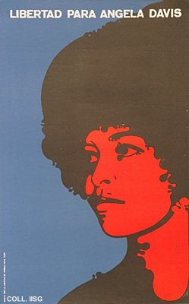 |  | Felix Beltrán, 1971  Freedom for Angela Davis  (Offset, 57x35 cm., inv.nr. BG D12/829)  The black activist Angela Davis campaigns for reforms in American justice, especially concerning racial issues. In 1970 she is arrested and imprisoned herself. Her case arouses indignation world-wide. In 1972, Angela Davis is released.  The styling of this portrait, with flat colours and rounded forms, shows the influence of Pop Art

