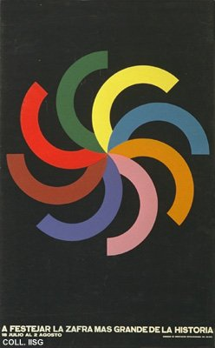 |  | Designer unknown, 1970  To celebrate the biggest harvest in history  Publisher: Comisión de Orientación Revolucionaria  (Silkscreen, 89x55 cm., inv.nr. BG E3/816)  With 8.5 million tons, the 1970 sugar harvest is the biggest in history. In an attempt to overcome the disappointment of not gaining ten million tons, festivities are organized. Some time later it becomes apparent how the concentration on sugar cane has damaged the other sectors of agriculture and industry, leaving Cuba even more dependent on the Eastern bloc than before. The motif on this poster refers to festive fireworks and also to the machete, which is curved and is used in a circular, chopping motion

