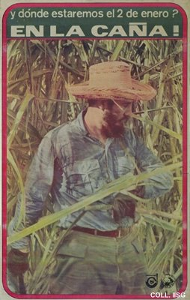 |  | Pedro Rodriguez, 1970  And where will we be on January 2? In the cane fields!  Publisher: Columna Juvenil de Centenario, UJC  (Offset, 94.5x60 cm., inv.nr. BG E10/963)  Sugar cane is Cuba's most important export product. To make the economy less dependent on aid from and trade with the Eastern bloc countries, it is decided to try to have a record harvest of ten million tons of sugar cane in 1970. A massive propaganda campaign is started to mobilize the population. Everyone is to help harvesting in their free time. On this poster Castro, who was born on a sugar farm incidentally, is shown giving a good example.

