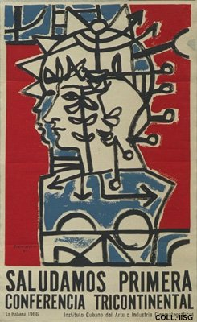 |  | Portocarrero, 1966  We salute the first Tricontinental Conference  Publisher: ICAIC  (Silkscreen, 86.5x53 cm., inv.nr. BG E10/961)  Poster for a conference on solidarity with the peoples of Africa, Asia and Latin America. As a result of this conference, OSPAAAL (Organización de Solidaridad con los Pueblos de Africa, Asia y America Latina) is founded

