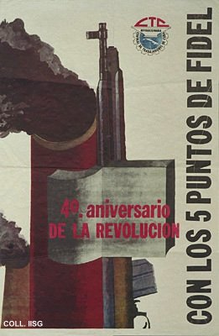 |  | Designer unknown, 1963  Fourth anniversary of the revolution  Publisher: Central de Trabajadores de Cuba  (Offset, 79x52 cm., inv.nr. BG E3/812)  An early attempt to avoid the socialist realist stereotypes of muscled workers and determined soldiers. The smoking chimney stack represents industry, the rifle the defence of the country and the open book the campaign against illiteracy

