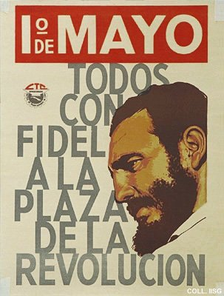 |  | Designer unknown, ca. 1965  May Day. All with Fidel on the Square of the Revolution  Publisher: Central de Trabajadores de Cuba  (53x40.5 cm., inv.nr. BG D12/777)  At the May Day meetings on the Square of the Revolution in Havana, Castro speeches for several hours on end. In these early years, he seriously tries to inform the Cuban people, illustrating his arguments with facts and figures and speaking openly about problems.

